S3 presign URL using CloudShell

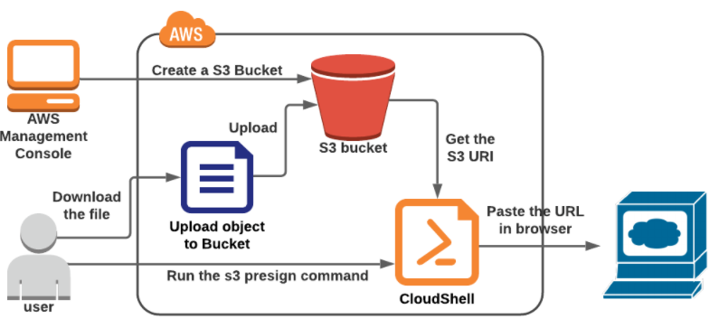

A presigned URL is **a URL that you can provide to your users to grant temporary access to a specific S3 object**. Using the URL, a user can either READ the object or WRITE an Object (or update an existing object).

Upload some objects in S3 bucket.

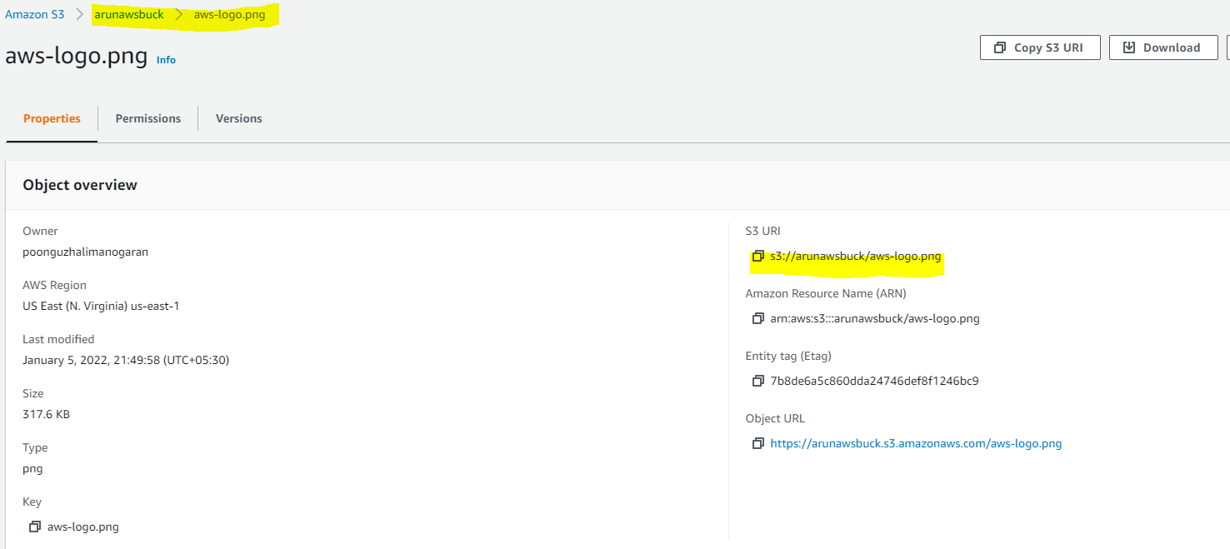

Access the object using object url

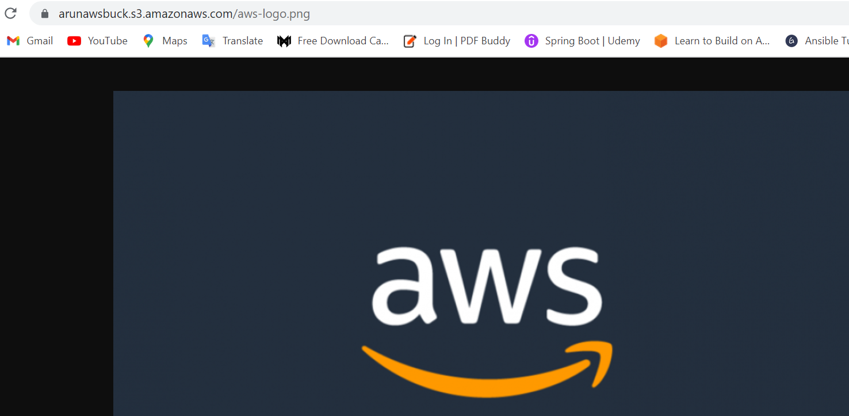

Open cloud shell and execute presign command for 60 sec

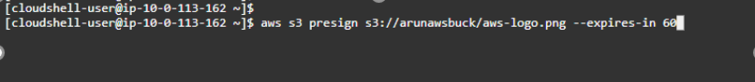



Access the presign generated URL

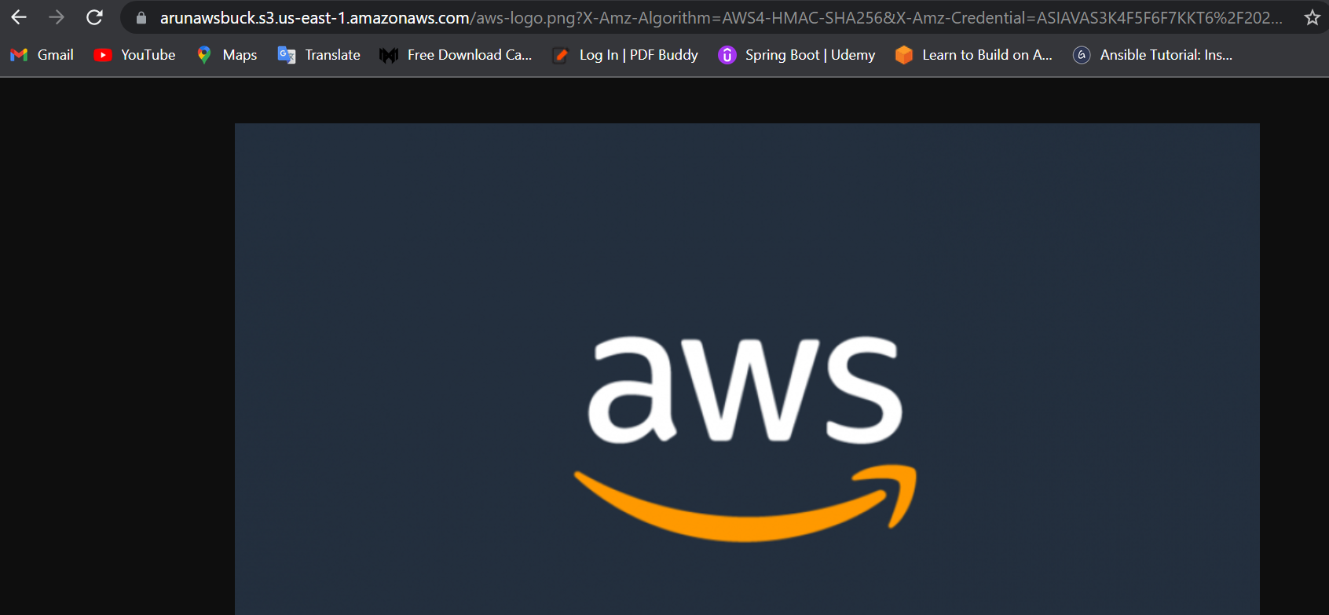

Now try the same URL after 60 sec you will see the access denied message.

